Dear Parents,
SECOND GRADE MATHEMATICS UNIT 6 STANDARDS

We want to make sure that you have an understanding of the mathematics your child will be learning this year. Below you will find the standards we will be learning in Unit Six. Each standard is in bold print and underlined and below it is an explanation with student examples. Your child is not learning math the way we did when we were in school, so hopefully this will assist you when you help your child at home. Please let your teacher know if you have any questions
☺

MGSE2.OA.3 Determine whether a group of objects (up to 20) has an odd or even number of members, e.g., by pairing objects or counting them by 2s; write an equation to express an even number as a sum of two equal addends.

This standard calls for students to apply their work with doubles addition facts to the concept of odd or even numbers. Students should have ample experiences exploring the concept that if a number can be decomposed (broken apart) into two equal addends (e.g., 10 = 5 +5), then that number (10 in this case) is an even number. Students should explore this concept with concrete objects (e.g., counters, place value cubes, etc.) before moving towards pictorial representations such as circles or arrays.

Example: Is 8 an even number? Prove your answer.
Student 1  I grabbed 8 counters. I paired counters up into groups of 2. Since I didn’t have any counters left over, I know that 8 is an even number. |  | Student 2  I grabbed 8 counters. I put them into 2 equal groups. There were 4 counters in each group, so 8 is an even number.
Student 3  I drew 8 boxes in a rectangle that had two columns. Since every box on the left matches a box on the right, I know 8 is even. |  | Student 4  I drew 8 circles. I matched one on the left with one on the right. Since they all match up, I know that 8 is an even number.
Student 5 I know that 4 plus 4 equals 8. So 8 is an even number.

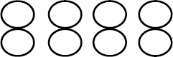
Find the total number of objects below.

Student 1  I see 3 counters in each column and there are |  | Student 2  I see 4 counters in each row and there are 3

4 columns. So, I added: 3 + 3 + 3+ 3. That  equals 12. |  | rows. So, I added 4 + 4 + 4. That equals 12.

MGSE2.OA.4 Use addition to find the total number of objects arranged in rectangular arrays with up to 5 rows and up to 5 columns; write an equation to express the total as a sum of equal addends.

Second graders use rectangular arrays to work with repeated addition, a building block for multiplication in third grade. A rectangular array is any arrangement of things in rows and columns, such as a rectangle of square tiles. Students explore this concept with concrete objects (e.g., counters, counting bears, square tiles, etc.) as well as pictorial representations on grid paper or other drawings. Due to the commutative property of multiplication, students can add either the rows or the columns and still arrive at the same solution.

Example: What is the total number of circles below?

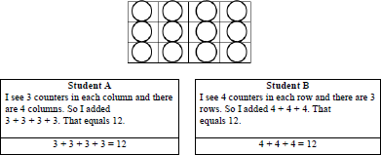

MGSE2.MD.10 Draw a picture graph and a bar graph (with single-unit scale) to represent a data set with up to four categories. Solve simple put-together, take-apart, and compare problems using information presented in a bar graph. This standard continues throughout the 2nd grade year.

This standard calls for students to work with categorical data by organizing, representing and interpreting data. Students should have experiences posing a question with 4 possible responses and then work with the data that they collect.

Example: Students pose a question and the 4 possible responses. Which is your favorite flavor of ice cream: Chocolate, vanilla, strawberry, or cherry?

Students collect their data by using tallies or another way of keeping track. Students organize their data by totaling each category in a chart or table. Picture and bar graphs are introduced in 2nd Grade.

Flavor | Number of People
Chocolate | 12
Vanilla | 5
Strawberry | 6
Cherry | 9
Students display their data using a picture graph or bar graph using a single unit scale.

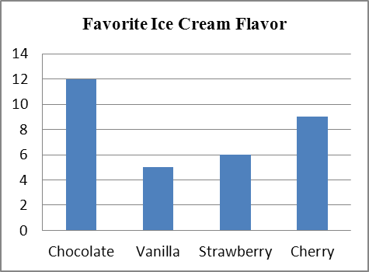 represents 1 student
Favorite Ice Cream Flavor
Chocolate | 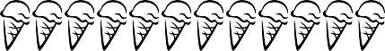
Vanilla | 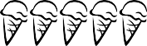
Strawberry | 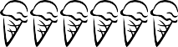
Cherry | 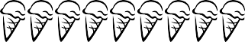

Students answer simple problems related to addition and subtraction that ask them to put together, take apart, and compare numbers. See Table 1 at the end of this document for examples of these.

