THIRD GRADE MATHEMATICS
UNIT 3
Dear Parents,

We want to make sure that you have an understanding of the mathematics your child will be learning this year. Below you will find the standards we will be learning in Unit Three. Each standard is in bold print and underlined and below it is an explanation with student examples. Your child is not learning math the way we did when we were in school, so hopefully this will assist you when you help your child at home. Please let your teacher know if you have any questions.

MGSE.3.OA.8 Solve two-step word problems using the four operations. Represent these problems using equations with a letter standing for the unknown quantity. Assess the reasonableness of answers using mental computation and estimation strategies including rounding.
This standard refers to two-step word problems using the four operations. The size of the numbers should be limited. Adding and subtracting numbers should include numbers within 1,000, and multiplying and dividing numbers should include single-digit factors and products less than 100.
This standard calls for students to represent problems using equations with a letter to represent unknown quantities.
Example:
Mike runs 2 miles a day. His goal is to run 25 miles. After 5 days, how many miles does Mike have left to run to meet his goal? Write an equation and find the solution (2 x 5 + m = 25).
This standard refers to estimation strategies, including using compatible numbers (numbers that sum to 10, 50, or 100) or rounding. The focus in this standard is to have students use and discuss various strategies.
Students should estimate during problem solving, and then revisit their estimate to check for reasonableness.
Example: Here are some typical estimation strategies for the problem:
On a vacation, your family travels 267 miles on the first day, 194 miles on the second day and 34 miles on the third day. How many total miles did they travel?

Student 1  I first thought about 267 and 34. I noticed that their sum is about 300. Then I knew that 194 is close to 200. When I put 300 and 200 together, I  get 500. |  | Student 2  I first thought about 194. It is really close to 200. I also have 2 hundreds in  267. That gives me a total of 4 hundreds. Then I have 67 in 267 and the 34. When I put 67 and 34 together that is really close to 100. When I add that hundred to the 4 hundreds that I already had, I end up with 500. |  | Student 3  I rounded 267 to 300. I  rounded 194 to 200. I  rounded 34 to 30. When I  added 300, 200, and 30, I know my answer will be about 530.
The assessment of estimation strategies should only have one reasonable answer (500 or 530), or a range (between 500 and 550). Problems should be structured so that all acceptable estimation strategies will arrive at a reasonable answer.

MGSE.3.OA.9 Identify arithmetic patterns (including patterns in the addition table or multiplication table) and explain them using properties of operations. For example, observe that 4 times a number is always even, and explain why 4 times a number can be decomposed into two equal addends.
This standard calls for students to examine arithmetic patterns involving both addition and multiplication. Arithmetic patterns are patterns that change by the same rate, such as adding the same number. For example, the series 2, 4, 6, 8, 10 is an arithmetic pattern that increases by 2 between each term.
This standard also mentions identifying patterns related to the properties of operations.
Examples:

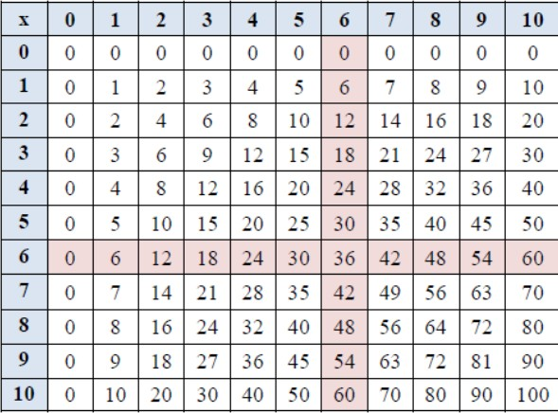
- Even numbers are always divisible by 2. Even numbers can always be decomposed into 2 equal addends (14 = 7 + 7).
- Multiples of even numbers (2, 4, 6, and 8) are always even numbers.
- On a multiplication chart, the products in each row and column increase by the same amount (skip counting).
- On an addition chart, the sums in each row and column increase by the same amount.
What do you notice about the numbers highlighted in pink in the multiplication table? Explain a pattern using properties of operations. When one changes the order of the factors
(commutative property), they will still get the same product; example 6 x 5 = 30 and 5 x 6 = 30.

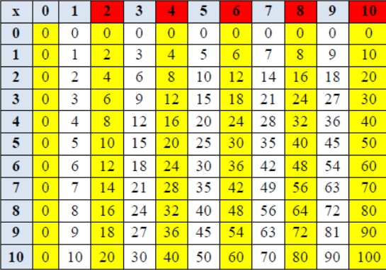
Teacher: What pattern do you notice when 2, 4, 6, 8, or 10 are multiplied by any number (even or odd)?
Student: The product will always be an even number. Teacher: Why?
What patterns do you notice in this addition table? Explain why the pattern works this way?

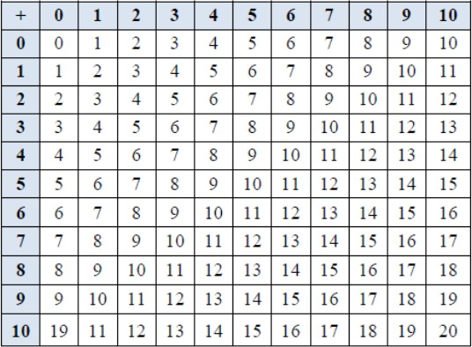
Students need ample opportunities to observe and identify important numerical patterns related to operations. They should build on their previous experiences with properties related to addition and subtraction. Students investigate addition and multiplication tables in search of patterns and explain why these patterns make sense mathematically.
Examples:
- Any sum of two even numbers is even.
- Any sum of two odd numbers is even.
- Any sum of an even number and an odd number is odd.
- The multiples of 4, 6, 8, and 10 are all even because they can all be decomposed into two equal groups.
- The doubles (2 addends the same) in an addition table fall on a diagonal while the doubles (multiples of 2) in a multiplication table fall on horizontal and vertical lines.
- The multiples of any number fall on a horizontal and a vertical line due to the commutative property.
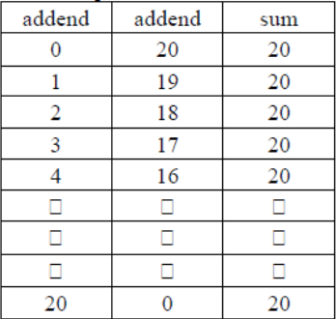
- All the multiples of 5 end in a 0 or 5 while all the multiples of 10 end with 0. Every other multiple of 5 is a multiple of 10.

Students also investigate a hundreds chart in search of addition and subtraction patterns. They record and organize all the different possible sums of a number and explain why the pattern makes sense.

MGSE3.MD.3 Draw a scaled picture graph and a scaled bar graph to represent a data set with several categories. Solve one- and two-step “how many more” and “how many less” problems using information presented in scaled bar graphs. For example, draw a bar graph in which each square in the bar graph might represent 5 pets.

This standard continues throughout the third grade year.

Students should have opportunities reading and solving problems using scaled graphs before being asked to draw one. The following graphs all use five as the scale interval, but students should experience different intervals to further develop their understanding of scale graphs and number facts. While exploring data concepts, students should Pose a question, Collect data, Analyze data, and Interpret data (PCAI). Students should be graphing data that is relevant to their lives
Example:
Pose a question: Student should come up with a question. What is the typical genre read in our class?
Collect and organize data: student survey
Pictographs: Scaled pictographs include symbols that represent multiple units. Below is an example of a pictograph with symbols that represent multiple units. Graphs should include a title, categories, category label, key, and data. How many more books did Juan read than Nancy?

Number of Books Read
Nancy
Juan
= 5 books

Single Bar Graphs: Students use both horizontal and vertical bar graphs. Bar graphs include a title, scale, scale label, categories, category label, and data.
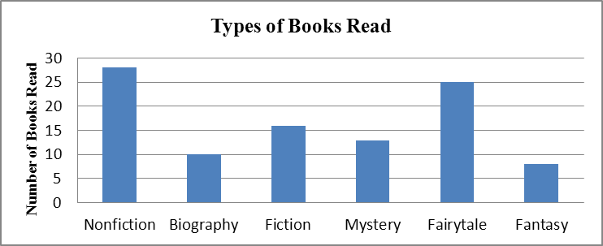

Analyze and Interpret data:
- How many more nonfiction books where read than fantasy books?
- Did more people read biography and mystery books or fiction and fantasy books?
- About how many books in all genres were read?
- Using the data from the graphs, what type of book was read more often than a mystery but less often than a fairytale?
- What interval was used for this scale?
- What can we say about types of books read? What is a typical type of book read?
- If you were to purchase a book for the class library which would be the best genre? Why?

MGSE3.MD.4 Generate measurement data by measuring lengths using rulers marked with halves and fourths of an inch. Show the data by making a line plot, where the horizontal scale is marked off in appropriate units – whole numbers, halves, or quarters.
This standard continues throughout the third grade year.

Students in second grade measured length in whole units using both metric and U.S. customary systems. It is important to review with students how to read and use a standard ruler including details about halves and quarter marks on the ruler. Students should connect their understanding of fractions
to measuring to one-half and one-quarter inch. Third graders need many opportunities measuring the length of various objects in their environment. This standard provides a context for students to work with fractions by measuring objects to a quarter of an inch. Example: Measure objects in your desk to the nearest ½ or ¼ of an inch, display data collected on a line plot. How many objects measured ¼?
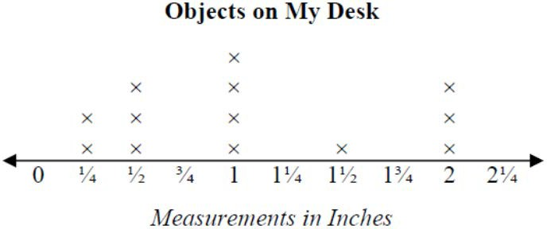
½? etc. …

MGSE.3.MD.5 Recognize area as an attribute of plane figures and understand concepts of area measurement.
- A square with side length 1 unit, called “a unit square,” is said to have “one square unit” of area, and can be used to measure area.
- A plane figure which can be covered without gaps or overlaps by n unit squares is said to have an area of n square units.
These standards call for students to explore the concept of covering a region with “unit squares,” which could include square tiles or shading on grid or graph paper.

 |  |  |  |  | 4
 |  | 5 |  |  | One square  unit

MGSE.3.MD.6 Measure areas by counting unit squares (square cm, square m, square in, square ft, and improvised units).
Students should be counting the square units to find the area could be done in metric, customary, or non- standard square units. Using different sized graph paper, students can explore the areas measured in square centimeters and square inches.

MGSE3.MD.7 Relate area to the operations of multiplication and addition.
- Find the area of a rectangle with whole-number side lengths by tiling it and show that the area is the same as would be found by multiplying the side lengths.
Students should tile rectangles then multiply their side lengths to show it is the same.
To find the area, one could count the squares or multiply 3
1 | 2 | 3 | 4
5 | 6 | 7 | 8
9 | 10 | 11 | 12

 4 = 12.

Multiply side lengths to find areas of rectangles with whole-number side lengths in the context of solving real world and mathematical problems and represent whole-number products as rectangular areas in mathematical reasoning.
Students should solve real world and mathematical problems
Example: Drew wants to tile the bathroom floor using 1 foot tiles. How many tiles will he need?
6 feet

8 feet
- Use tiling to show in a concrete case that the area of a rectangle with whole-number side lengths a and b + c is the sum of a × b and a × c. Use area models to represent the distributive property in mathematical reasoning.
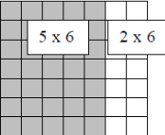
This standard extends students’ work with the distributive property. For example, in the picture below the area of a 7  6 figure can be determined by finding the area of a 5  6 and 2  6 and adding the two sums.
Example:
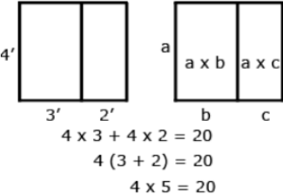

Common Misconceptions
Students may confuse perimeter and area when they measure the sides of a rectangle and then multiply. They think the attribute they find is length, which is perimeter. Pose problems situations that require students to explain whether they are to find the perimeter or area.

